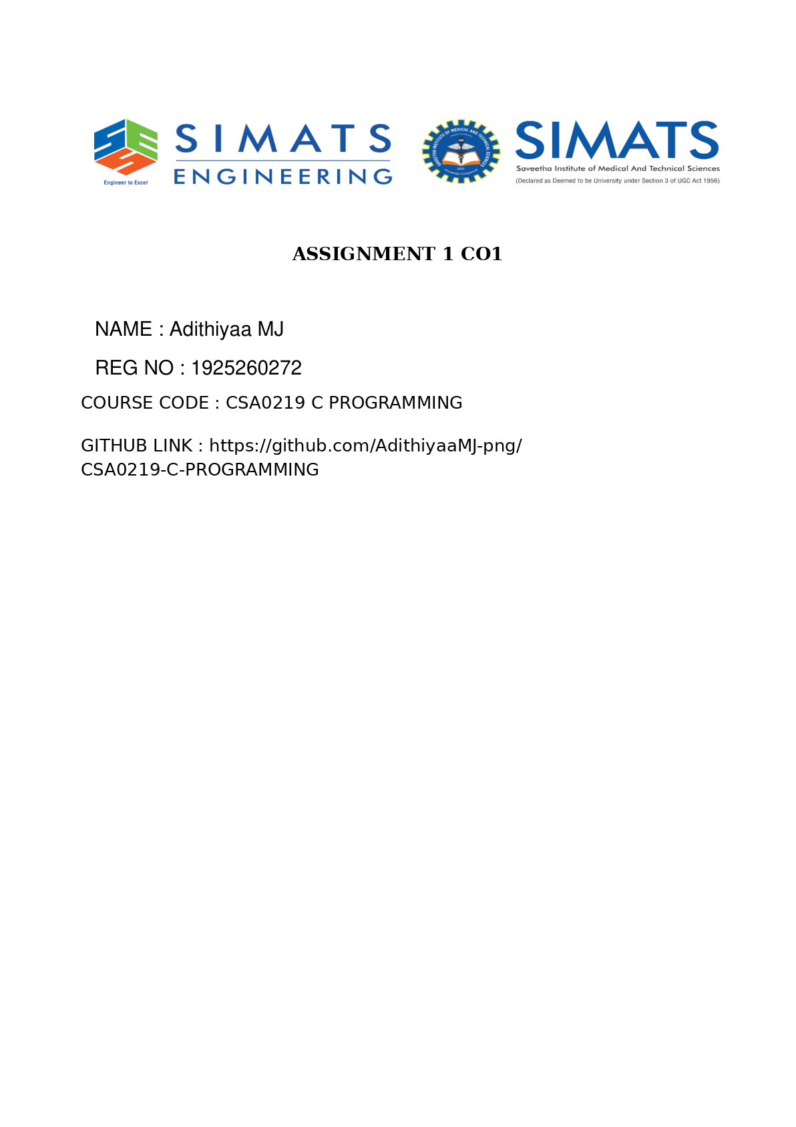

TASK 1 — Understand the Problem and Identify the Data
Grama Jyothi Rural Electricity Co-operative requires a fault-tolerant, paisa-exact C billing engine capable of scaling from 4,000 households (village) to 60,000 (taluk) and 800,000 (district). The legacy spreadsheet failed due to three root causes: (1) binary floating-point rounding errors causing paise discrepancies, (2) naive subtraction (current - previous) yielding negative bills when 16-bit electromechanical meter registers roll over from 65535 to 0, and (3) scattered hardcoded tariff constants causing partial rate updates.
1.1 Complete Data Item Identification & Justification
Data Item | Role | Mutability | Value Characteristics & Justification
household_id | Input | Per-record | Positive integer (1 to 800,000+ at district scale); uniquely identifies each connection.
consumer_category | Input | Per-record | Discrete code (e.g., Domestic = 1, Commercial = 2) selecting applicable slab/fixed tariffs.
prev_reading | Input | Per-record | Non-negative integer in [0, 65535]; 16-bit meter register snapshot from prior billing cycle.
curr_reading | Input | Per-record | Non-negative integer in [0, 65535]; may be numerically smaller than prev_reading upon rollover.
units_consumed | Computed / Output | Per-record | Non-negative integer in [0, 65535]; computed modulo 65536 to handle counter wrap-around.
SLAB1_UNITS, SLAB2_UNITS | Configuration | Constant | Compile-time constants (100, 200); remain invariant throughout an entire billing run.
RATE1..3_PAISE | Configuration | Constant | Tariff rates stored in integer paise (0, 225, 450) to eliminate decimal representation error.
FIXED_CHARGE_PAISE | Configuration | Constant | Monthly base charge in paise (5000L = Rs 50.00); applied even when consumption is 0 units.
energy_charge_paise | Computed / Output | Per-record | Non-negative integer sum of slab charges; grows linearly with units_consumed.
total_bill_paise | Computed / Output | Per-record | Exact sum fixed_charge_paise + energy_charge_paise; guaranteed >= FIXED_CHARGE_PAISE.
district_total_paise | Accumulator | Aggregate | Very large integer across 800,000 bills (~Rs 40–80 crore = up to 8 x 10^10 paise); requires 64-bit integer.

1.2 Billing Invariants (Rules Every Valid Bill Must Satisfy) & Operational Assumptions
- Non-Negativity Invariant: units_consumed >= 0 and total_bill_paise >= FIXED_CHARGE_PAISE > 0. No valid household bill can ever be negative or zero.
- Additive Decomposition Invariant: total_bill_paise == fixed_charge_paise + energy_charge_paise, and batch grand total equals the exact sum of individual bills.
- Slab Monotonicity Invariant: If units_A > units_B, then total_bill(A) >= total_bill(B); crossing a slab boundary never causes a downward jump.
- Single-Rollover Assumption: A 16-bit register wraps at most once per monthly cycle (consumption < 65,536 kWh). Readings where modulo difference exceeds a realistic domestic ceiling (e.g., 5,000 units/month) are flagged as meter faults/tampering.
Alternative Concept & Complexity Analysis — String Readings ("01530") vs. Integer Representation
• Solution Design: Reading meter values as fixed-width strings (char prev[6], curr[6]) requires validating every character via isdigit(), converting to integers via strtol() before arithmetic, or implementing manual digit-by-digit ASCII subtraction with borrow propagation across d characters.
• Time Complexity: Converting or comparing d-digit strings takes O(d) character operations per reading (for d = 5 digits, ~5-10x slower than a single CPU integer instruction). Integer arithmetic executes in O(1) time (1 CPU clock cycle).
• Space Complexity: A 5-digit reading plus null terminator ('\0') requires 6 bytes per reading (12 bytes per household pair), whereas a 16-bit unsigned short requires 2 bytes per reading (4 bytes per pair) — a 3x memory reduction (saving 6.4 MB across 800,000 district records).

TASK 2 — Choose the Data Types
Selecting appropriate C types prevents both silent arithmetic overflow at district scale and binary floating-point rounding drift.
Variable / Constant | Chosen C Type | sizeof (64-bit) | Range (limits.h / float.h) | District Scale Sufficiency
prev_reading, curr_reading | unsigned short (meter_t) | 2 bytes | 0 to 65,535 (USHRT_MAX) | Exact match for 16-bit hardware register.
units_consumed | unsigned int | 4 bytes | 0 to 4,294,967,295 (UINT_MAX) | Sufficient (max 65,535 << UINT_MAX).
household_id | unsigned int | 4 bytes | 0 to 4,294,967,295 | Sufficient for 800,000 district households.
consumer_category | unsigned char | 1 byte | 0 to 255 (UCHAR_MAX) | Sufficient for tariff category codes.
SLAB1_UNITS, SLAB2_UNITS | unsigned int | 4 bytes | 0 to 4,294,967,295 | Sufficient for kWh slab thresholds.
bill_paise (single bill) | long | 8 bytes (LP64) / 4B (LLP64) | -2^63 to 2^63-1 (or +-2.14e9) | Max single bill (~30M paise) fits easily.
district_total_paise | long long | 8 bytes | -9.22e18 to +9.22e18 (LLONG_MAX) | Essential: 800k bills ~ 10^11 paise exceeds 32-bit int/long.
float (rejected) | float (IEEE-754) | 4 bytes | 1.17e-38 to 3.40e38 (6-7 sig. digits) | INSUFFICIENT: Loses 1-paisa precision above Rs 167,772!

2.1 Why Money Must Not Be Stored as float Rupees
IEEE-754 single-precision float has only 24 bits of significand (~7.22 decimal digits). Decimal fractions like Rs 2.25 or Rs 0.10 cannot be represented cleanly in base-2 once totals grow. Specifically, once a running total exceeds 2^24 paise = 16,777,216 paise (Rs 1,67,772.16), the Unit in the Last Place (ULP) of float exceeds Rs 0.01 (1 paisa). Adding 4,000 household bills of Rs 162.53 each (exact = Rs 6,50,120.00) in float accumulates rounding drift (yielding Rs 6,50,120.38 — off by 38 paise). Storing all monetary values as integer paise in a 64-bit long long guarantees exact integer addition with zero rounding error.
2.2 Completed Code & Rollover Arithmetic Explanation
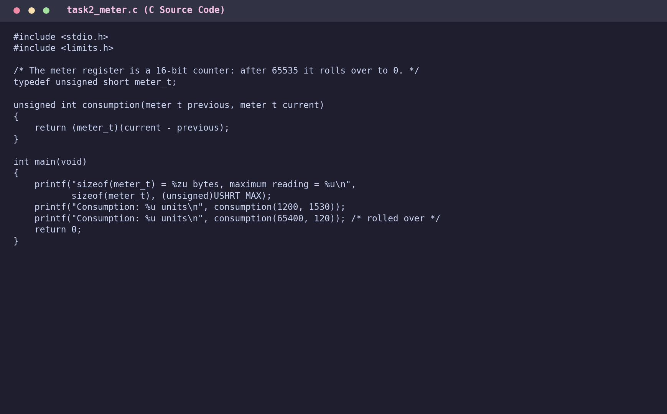
Figure 2.1: Completed task2_meter.c using modular unsigned 16-bit arithmetic
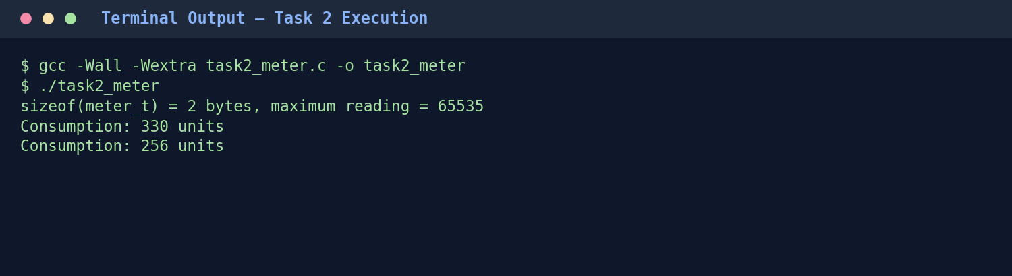
Figure 2.2: Compilation and execution output confirming 256-unit rollover calculation
Why the second result is 256 and not negative: In consumption(65400, 120), both parameters have type meter_t (unsigned short). Under C integer promotion rules, both values are promoted to int: 120 - 65400 = -65280. Casting this back to (meter_t) reduces the value modulo 2^16 (65536): (-65280 + 65536) mod 65536 = 256. Because meter_t is unsigned, wrap-around is well-defined by the C standard (ISO C99/C11 6.3.1.3) and never produces a negative number.
Alternative Concept & Complexity Analysis — double Rupees vs. long long Paise
• Solution & Rounding: Using double rupees (53-bit significand, ~15-17 decimal digits) requires calling round(charge * 100.0) / 100.0 after every slab multiplication and before formatting output to prevent tiny representation artifacts (e.g., 162.49999999999997).
• Time & Space: Both double and 64-bit integer addition take O(1) time (1 hardware ALU/FPU cycle) and occupy 8 bytes per value.
• Error Growth Over n Bills: With integer paise, cumulative rounding error is strictly 0 for all n up to 9 x 10^16 paise. With double rupees, each unrounded operation introduces up to 0.5 ULP (~10^-16 relative error), growing in the worst case as O(n * eps) or O(sqrt(n) * eps) for random rounding — negligible at n = 800,000 (~10^-8 Rs), yet integer paise remains strictly exact and avoids floating-point formatting edge cases.

TASK 3 — Define the Constants
3.1 #define vs. const Variables vs. enum
- #define Macros: Handled by the preprocessor via textual substitution before compilation. Ideal for configuration thresholds and literals (SLAB1_UNITS, RATE2_PAISE) because they require zero RAM/stack allocation and can be used in array sizes or #if directives. However, they lack type safety, obey file-level rather than block scope, and do not appear as symbols in gdb.
- const Qualified Variables: Typed read-only objects (e.g., const long RATE2_PAISE = 225L;) checked by the compiler, scoped to blocks/translation units, and inspectable in debuggers, though they may occupy read-only data (.rodata) memory.
- enum Constants: Compile-time int constants suited for mutually exclusive categorical states (e.g., enum Category { CAT_DOMESTIC = 1, CAT_COMMERCIAL = 2 };). Not suitable for 64-bit long long monetary totals because C restricts enum values to int.
- Naming Convention: ALL_CAPS_WITH_UNDERSCORES with explicit unit suffixes (_UNITS, _PAISE) and literal type suffixes (L, LL, U) to prevent accidental unit confusion or overflow.
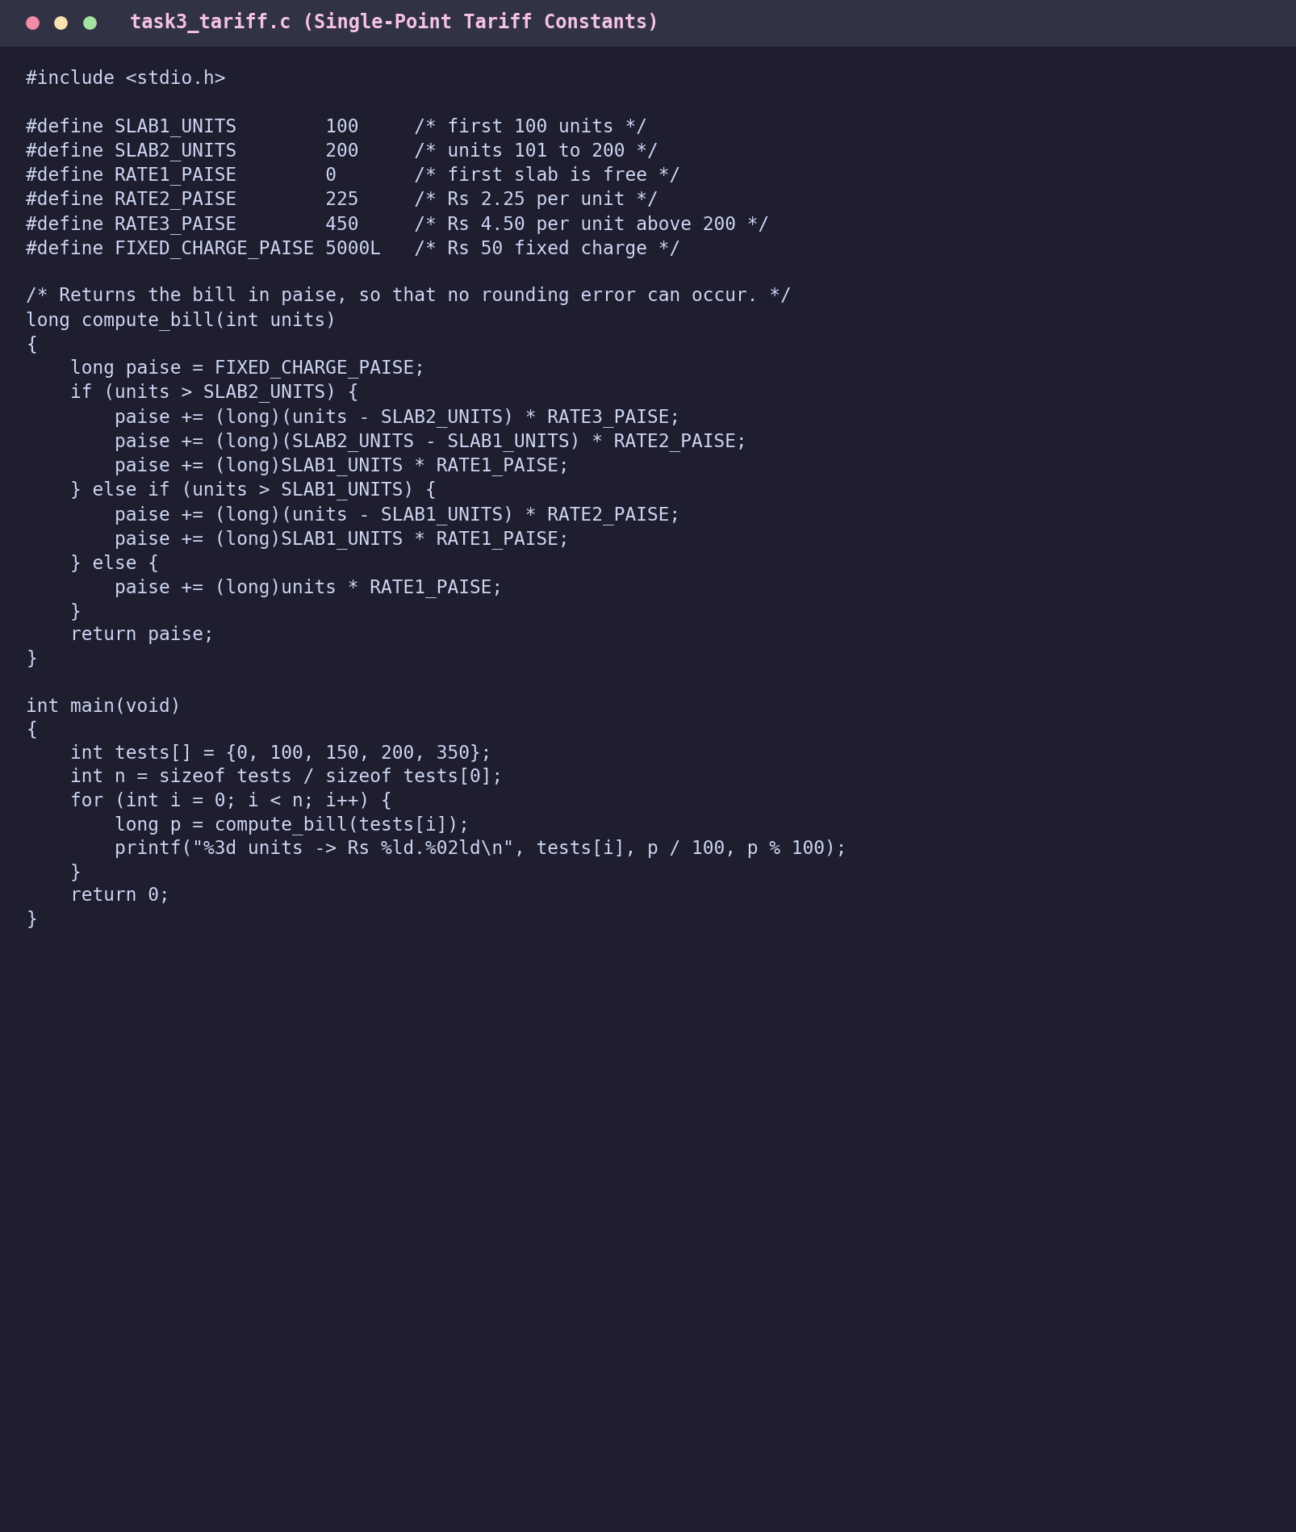
Figure 3.1: Single-source tariff macros and slab billing logic in task3_tariff.c
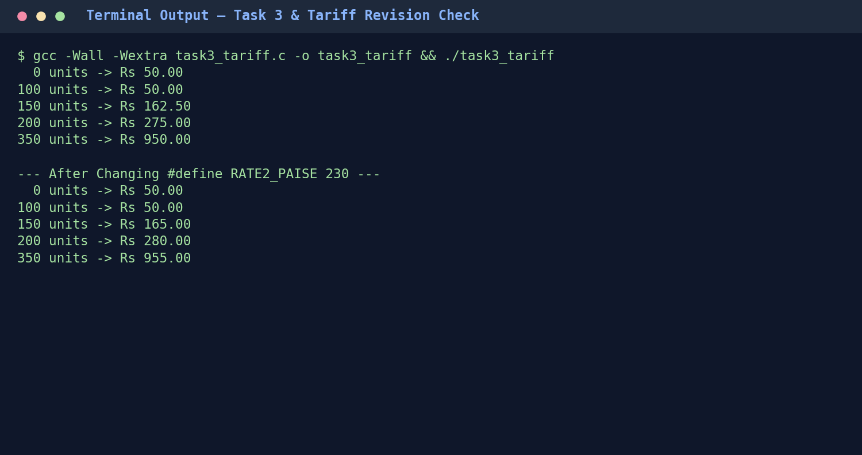
Figure 3.2: Execution output before and after revising RATE2_PAISE from 225 to 230
Alternative Concept & Complexity Analysis — const / enum vs. #define
• Program Changes: Replacing #define with const long enables strict type-checking and symbol visibility in gdb. Using enum restricts constants to 32-bit signed int.
• Memory & Runtime: #define and enum occupy 0 bytes of data memory (encoded directly as immediate operands in machine instructions). A const variable may occupy 4–8 bytes in .rodata if its address is taken or optimization (-O0) is disabled. At -O2, the compiler constant-folds both identically, so running time is completely unaffected (O(1)).

TASK 4 — Use Macros Safely
4.1 Preprocessor Expansion & Macro Pitfalls
- Operator Precedence Trap (SQUARE): If defined as #define SQUARE(x) x * x, then SQUARE(a + 1) expands textually to a + 1 * a + 1 = 2a + 1 (giving 9 instead of 25 when a = 4). Wrapping every parameter and the entire expression — #define SQUARE(x) ((x) * (x)) — expands to ((a + 1) * (a + 1)) = 25.
- Multiple Evaluation Side-Effect (MAX): #define MAX(a, b) (((a) > (b)) ? (a) : (b)) expands MAX(i++, j) to (((i++) > (j)) ? (i++) : (j)). When i > j, i++ executes twice, corrupting loop counters or stream reads.
- When Functions Are Better: Whenever arguments have side effects (i++, function calls), when type checking is required, or when logic spans multiple statements/loops.
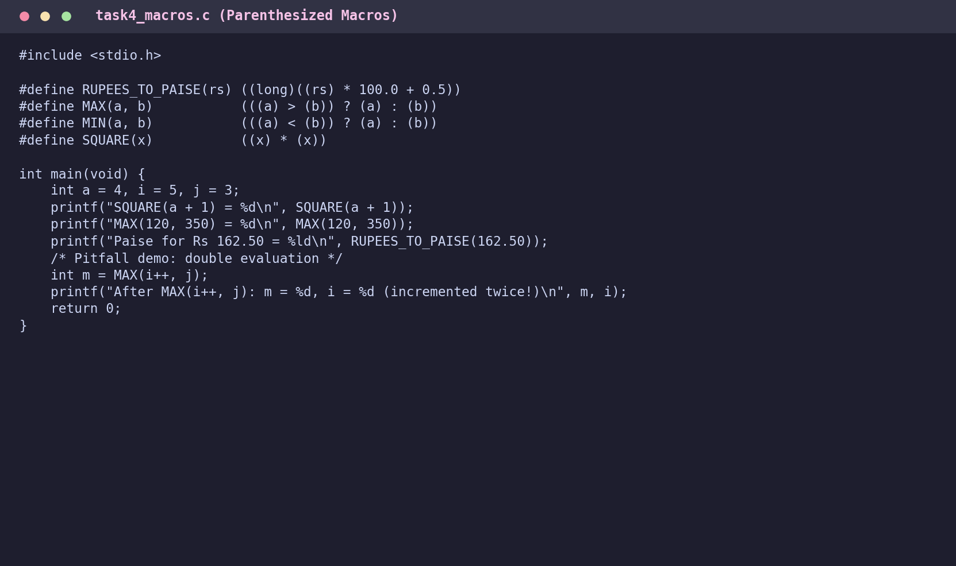
Figure 4.1: Fully parenthesized utility macros in task4_macros.c
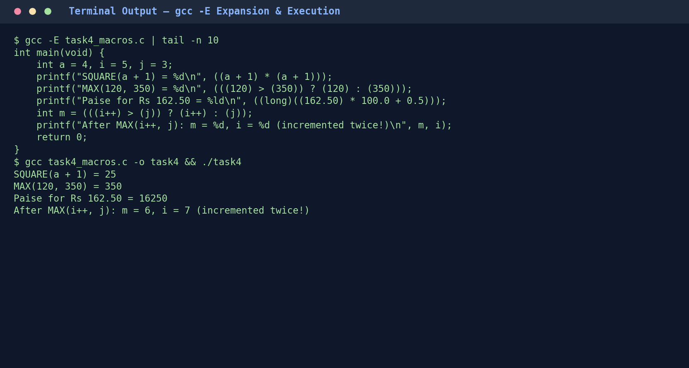
Figure 4.2: gcc -E preprocessed output proving textual expansion and double-increment behavior
Alternative Concept & Complexity Analysis — static inline Functions vs. Macros
• Solution: Defining static inline int max_int(int a, int b) { return a > b ? a : b; } evaluates arguments exactly once, enforces strict type checking, and obeys block scope.
• Time & Code Size (Space) across k Uses: With compiler optimization (-O2), static inline expands in-line just like a macro, achieving identical O(1) zero-call-overhead execution speed. Across k call sites, both inlined functions and macros duplicate machine instructions k times (O(k) code size); however, if k is large and the body is complex, the compiler can choose not to inline a static inline function to keep instruction cache footprint O(1), whereas a macro is always blindly expanded k times.

TASK 5 — Organise the Program with Header Files and Conditional Compilation
- Modular C Program Structure: Declarations (constants, typedefs, function prototypes) reside in billing.h; function implementations reside in billing.c; user I/O and batch orchestration reside in main.c.
- Include Guards (#ifndef BILLING_H ... #endif): Prevent duplicate symbol/typedef compilation errors if billing.h is included multiple times transitively across translation units.
- #include <file> vs. #include "file": Angle brackets (<stdio.h>) search system standard include directories first; double quotes ("billing.h") search the current project directory first before falling back to system paths.
- Conditional Compilation (-DDEBUG): Compiling with gcc -DDEBUG activates DBG_PRINT(...) macros to trace intermediate slab breakdowns on stderr; compiling without -DDEBUG strips all debug code completely at preprocess time.
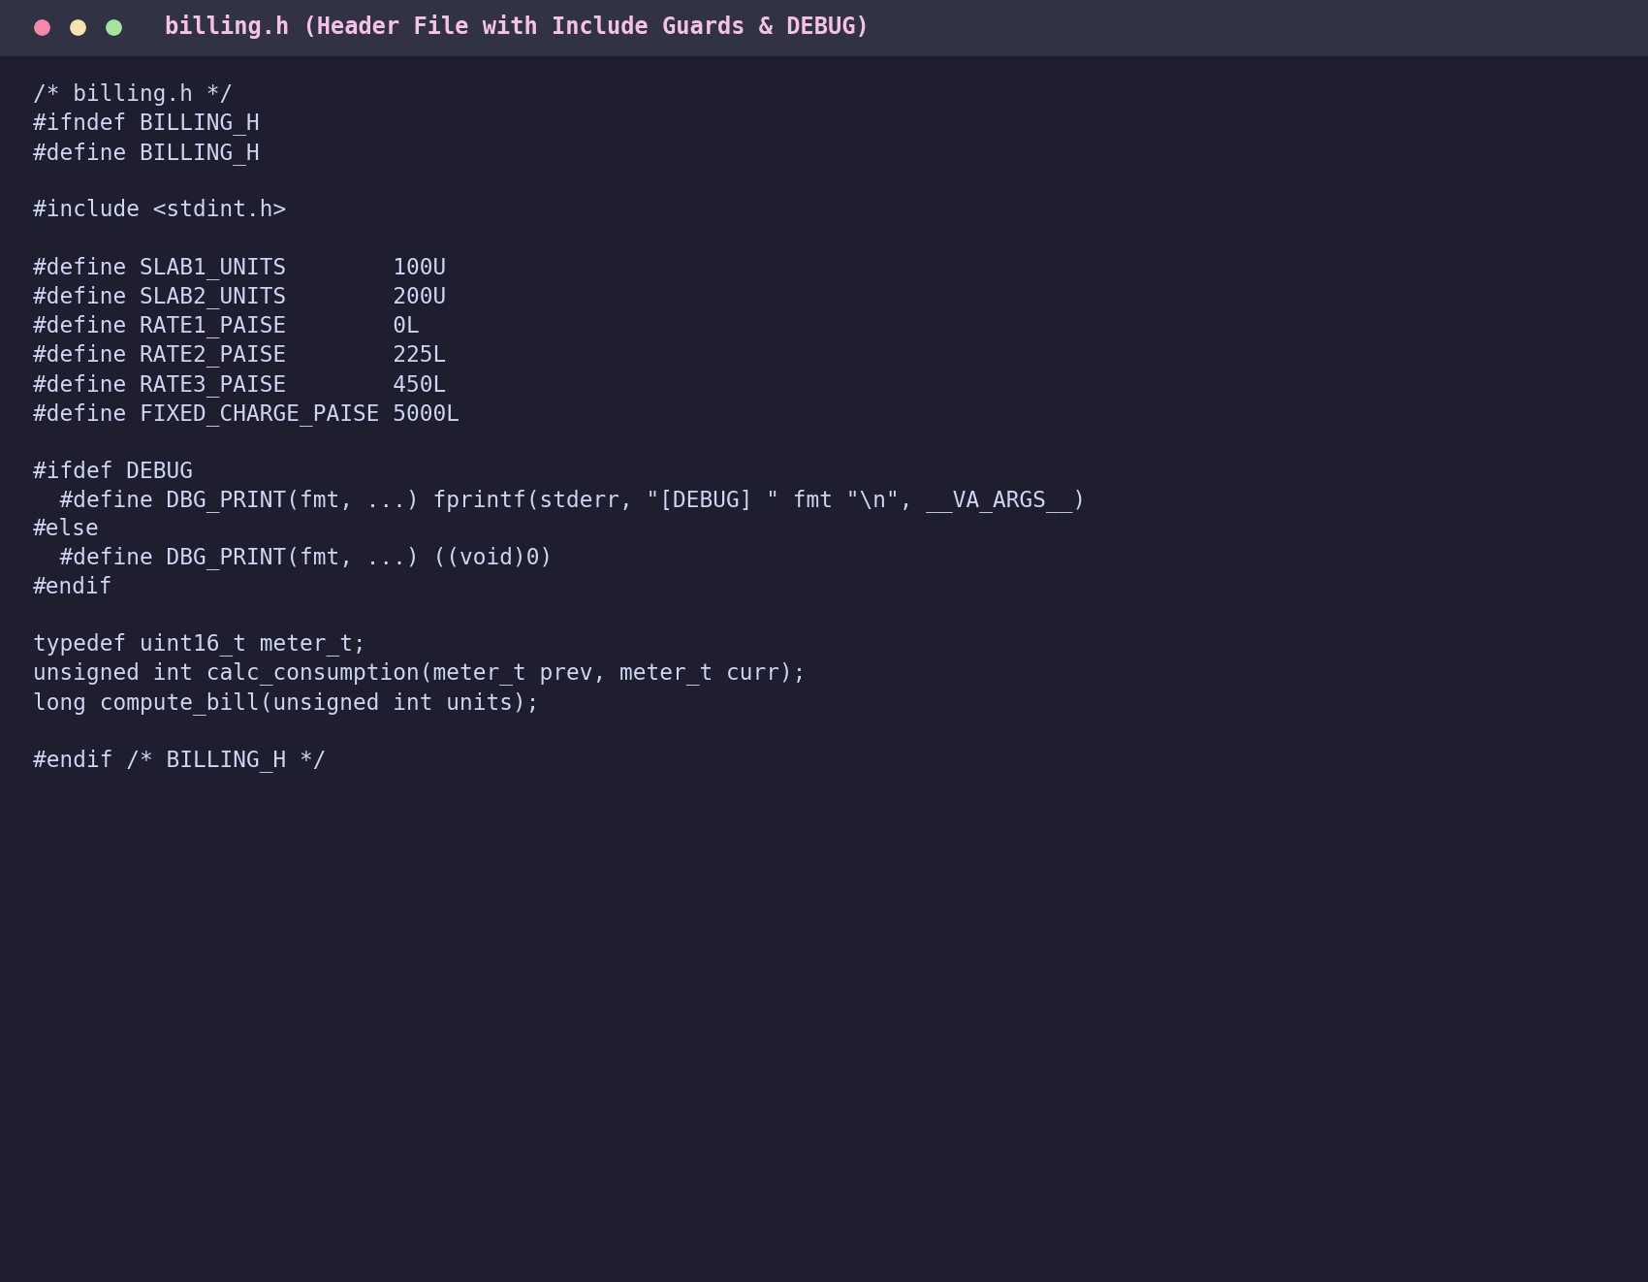
Figure 5.1: billing.h with include guards, shared constants, and conditional DBG_PRINT macro
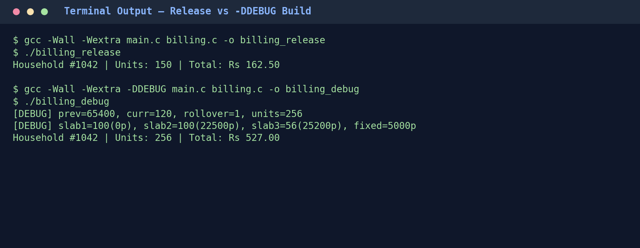
Figure 5.2: Comparison between production build and -DDEBUG diagnostic build
Alternative Concept & Complexity Analysis — Runtime if (debug) Flag vs. #ifdef DEBUG
• Solution: A runtime boolean (if (g_debug) fprintf(stderr, ...);) allows toggling logs via CLI flags (--debug) without recompiling.
• Time & Space Cost: At runtime, every billing loop iteration executes an extra branch instruction (O(1) per call, ~800,000 branch checks at district scale), and all debug format strings and fprintf call instructions remain compiled inside the binary (.rodata and .text), increasing executable size. By contrast, #ifdef DEBUG has zero runtime branch overhead and zero binary bloat in production builds.

TASK 6 — Read and Print Data Correctly
Format Specifier | Target C Data Type | Example Usage in Billing System | Consequence of Mismatch
%d | int (signed) | scanf("%d", &n); | Undefined behavior / truncation if passed a 64-bit long.
%u | unsigned int | printf("%u", units); | Prints huge positive garbage if passed a negative signed int.
%ld / %lld | long / long long | printf("%lld", grand_total_paise); | Using %d truncates upper 32 bits (see Fig 6.2).
%f / %lf | float / double (printf/scanf) | scanf("%lf", &rate); printf("%f", x); | scanf requires %lf for double; %f reads only 4 bytes and corrupts memory.
%c / %s | char / char[] string | scanf("%15s", meter_code); | Unbounded %s risks buffer overflow; always specify width.

- Validating scanf Return Value: scanf returns the exact count of successfully parsed items (or EOF). Checking if (scanf("%u %ld %ld", &hh_id, &prev, &curr) != 3) immediately catches alphabetic typos (e.g., "abc") before uninitialized variables enter billing math.
- Exact Currency Formatting: Integer paise p is formatted without floating-point conversion using integer division and remainder: printf("Rs %lld.%02lld", p / 100, p % 100); — ensuring 16250 prints as Rs 162.50 and 5005 prints as Rs 50.05.

TASK 7 — Control Type Conversion and Precision
- Implicit Conversions: Types narrower than int (unsigned short, char) undergo integer promotion to int during arithmetic. When mixing signed and unsigned operands of equal rank (int and unsigned int), usual arithmetic conversions convert the signed operand to unsigned.
- Integer Division Truncation: In C, 150 / 100 evaluates to 1 (truncating .50). Computing (units / 100) * 225 loses fractional slab units; multiplication must precede division, or rates must be expressed per single unit in paise.
- Explicit Casting & Narrowing: Casting a 64-bit long total (e.g., 3,000,000,000 paise) to 32-bit int wraps around to a negative number (-1,294,967,296).
- Consistent Rounding Rule: When converting fractional rupee rates to integer paise, apply round-to-nearest-even or half-up: (long long)(amount_rs * 100.0 + 0.5) once at configuration load, then perform 100% integer arithmetic thereafter.
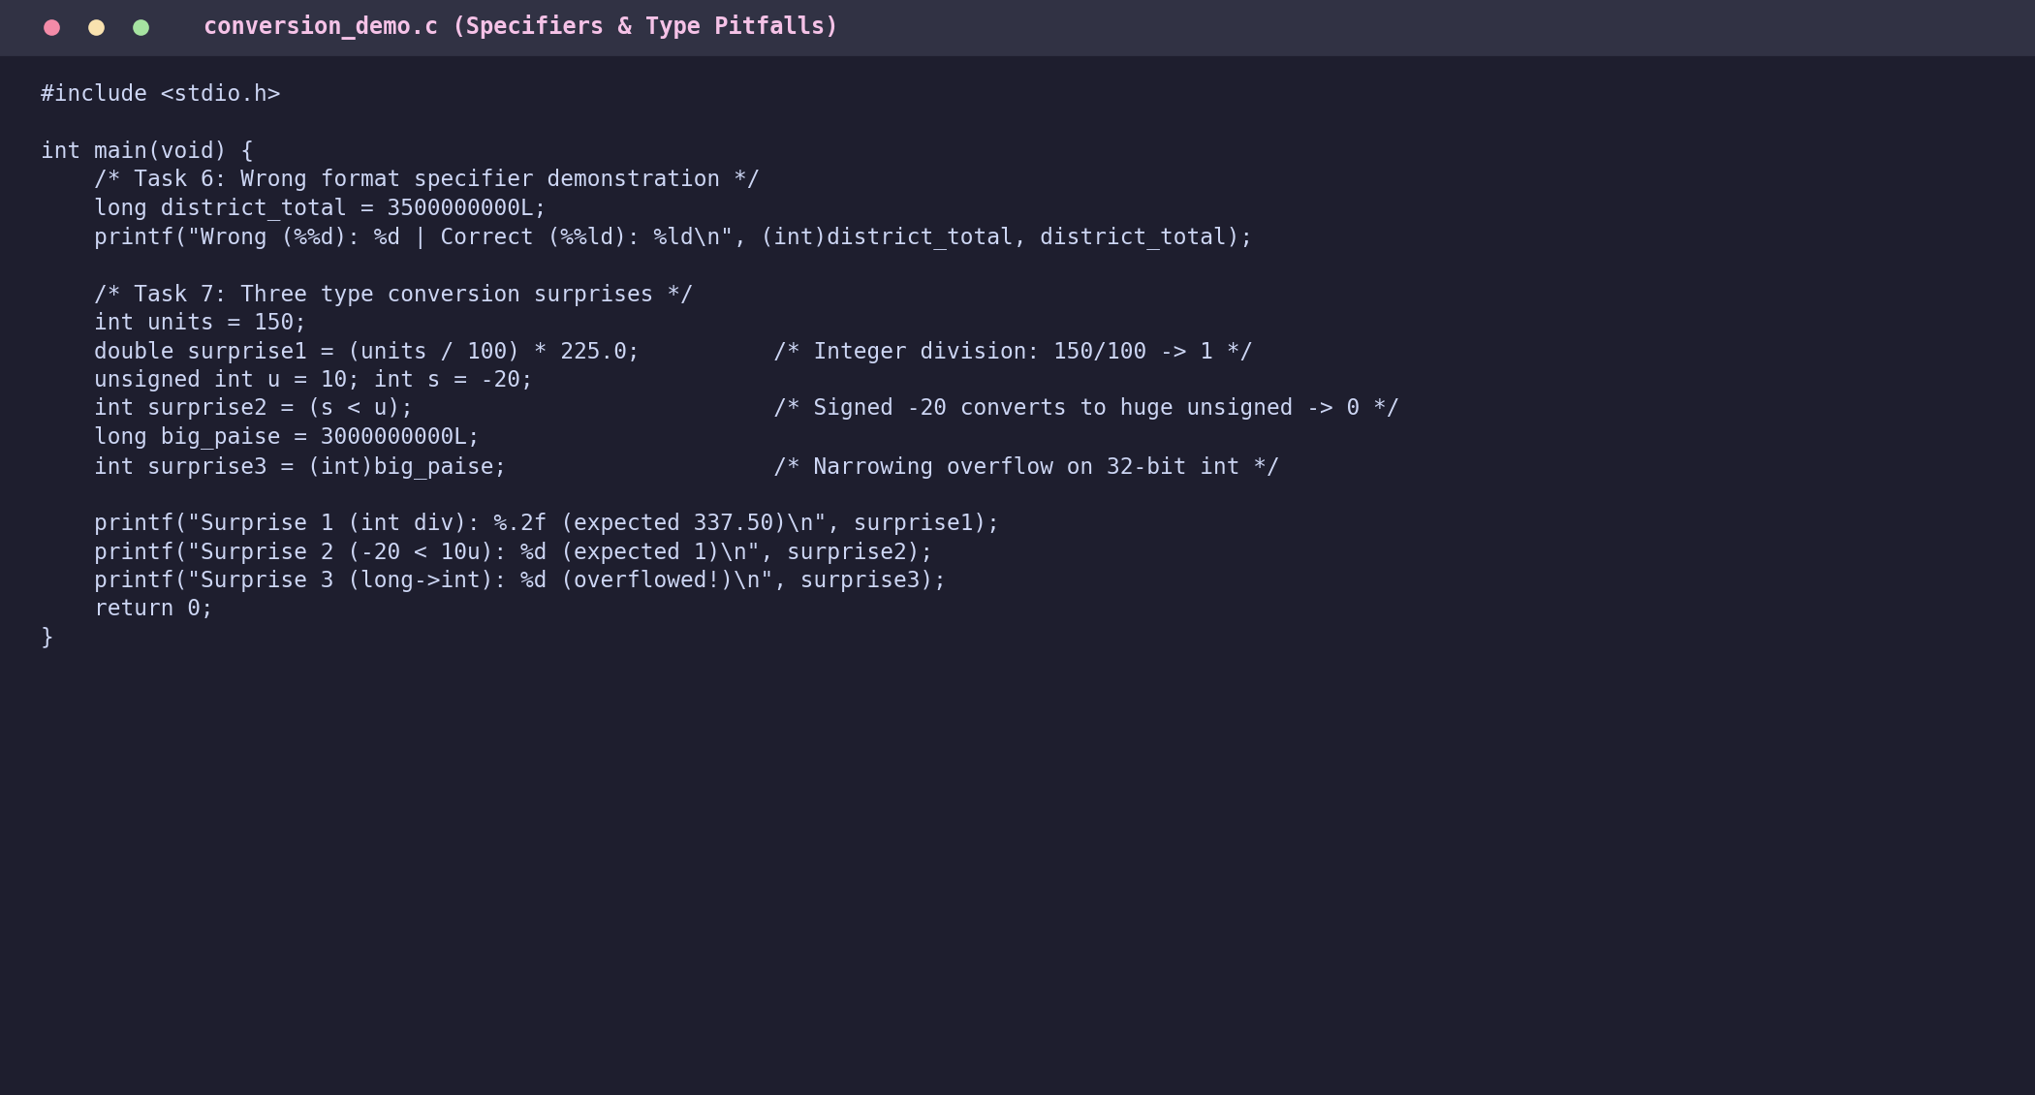
Figure 7.1: Demonstration of wrong format specifier and three type conversion pitfalls
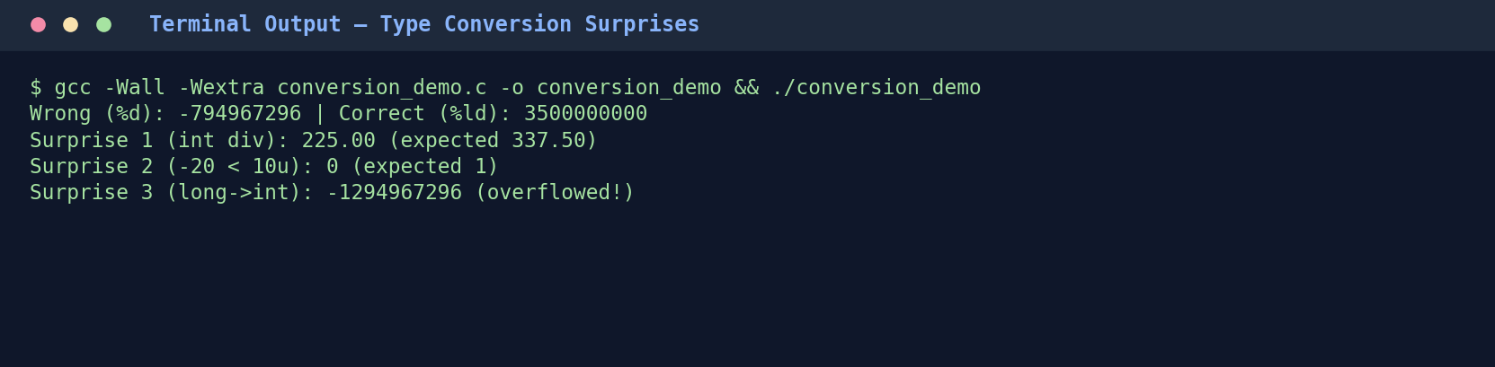
Figure 7.2: Execution output revealing silent truncation, signed/unsigned wrap, and narrowing overflow

TASK 8 — Trace the Compilation Process
Stage | GCC Command | Output Artifact | What Happens Internally
1. Preprocessing | gcc -E billing.c -o billing.i | Expanded C source (.i) | Strips comments, pastes <stdio.h> headers, expands #define macros, resolves #ifdef DEBUG.
2. Compilation | gcc -S billing.i -o billing.s | Assembly code (.s) | Parses syntax/types, optimizes slab branches, emits target CPU assembly instructions.
3. Assembly | gcc -c billing.s -o billing.o | Object file (.o) | Translates assembly into machine opcodes with unresolved external symbol references (printf).
4. Linking | gcc billing.o -o billing_app | Executable binary | Resolves printf/scanf against C standard library (libc) and writes OS executable header.

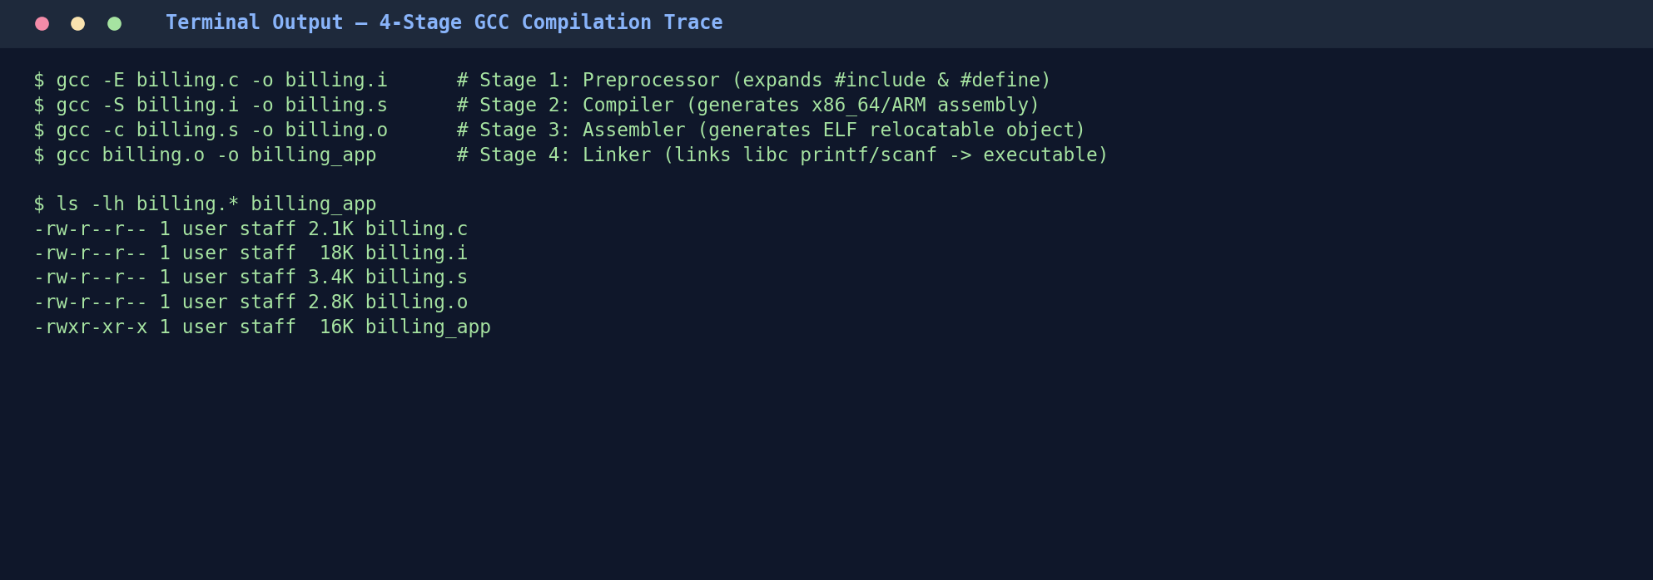
Figure 8.1: File sizes and artifacts across the 4-stage GCC compilation pipeline
8.1 Classification of Errors & Compiler Warnings (-Wall -Wextra)
- Compile-Time Error: Syntax or type violation caught during Stage 2 — e.g., omitting a semicolon after SLAB1_UNITS or passing incompatible pointer types to compute_bill().
- Link-Time Error: Unresolved external symbol caught during Stage 4 — e.g., declaring long compute_bill(int); in billing.h without linking billing.o (undefined reference to `compute_bill').
- Run-Time Error: Logical or input fault during execution — e.g., dividing by zero or signed integer overflow when accumulating district totals in a 32-bit int.
- Resolving -Wall -Wextra Warnings: Enabled warnings flagged -Wsign-compare (comparing int units with unsigned SLAB1_UNITS) and -Wformat (printing long with %d); resolved by standardizing unit variables as unsigned int and matching %lld specifiers.

TASK 9 — Implement and Test the Billing Program
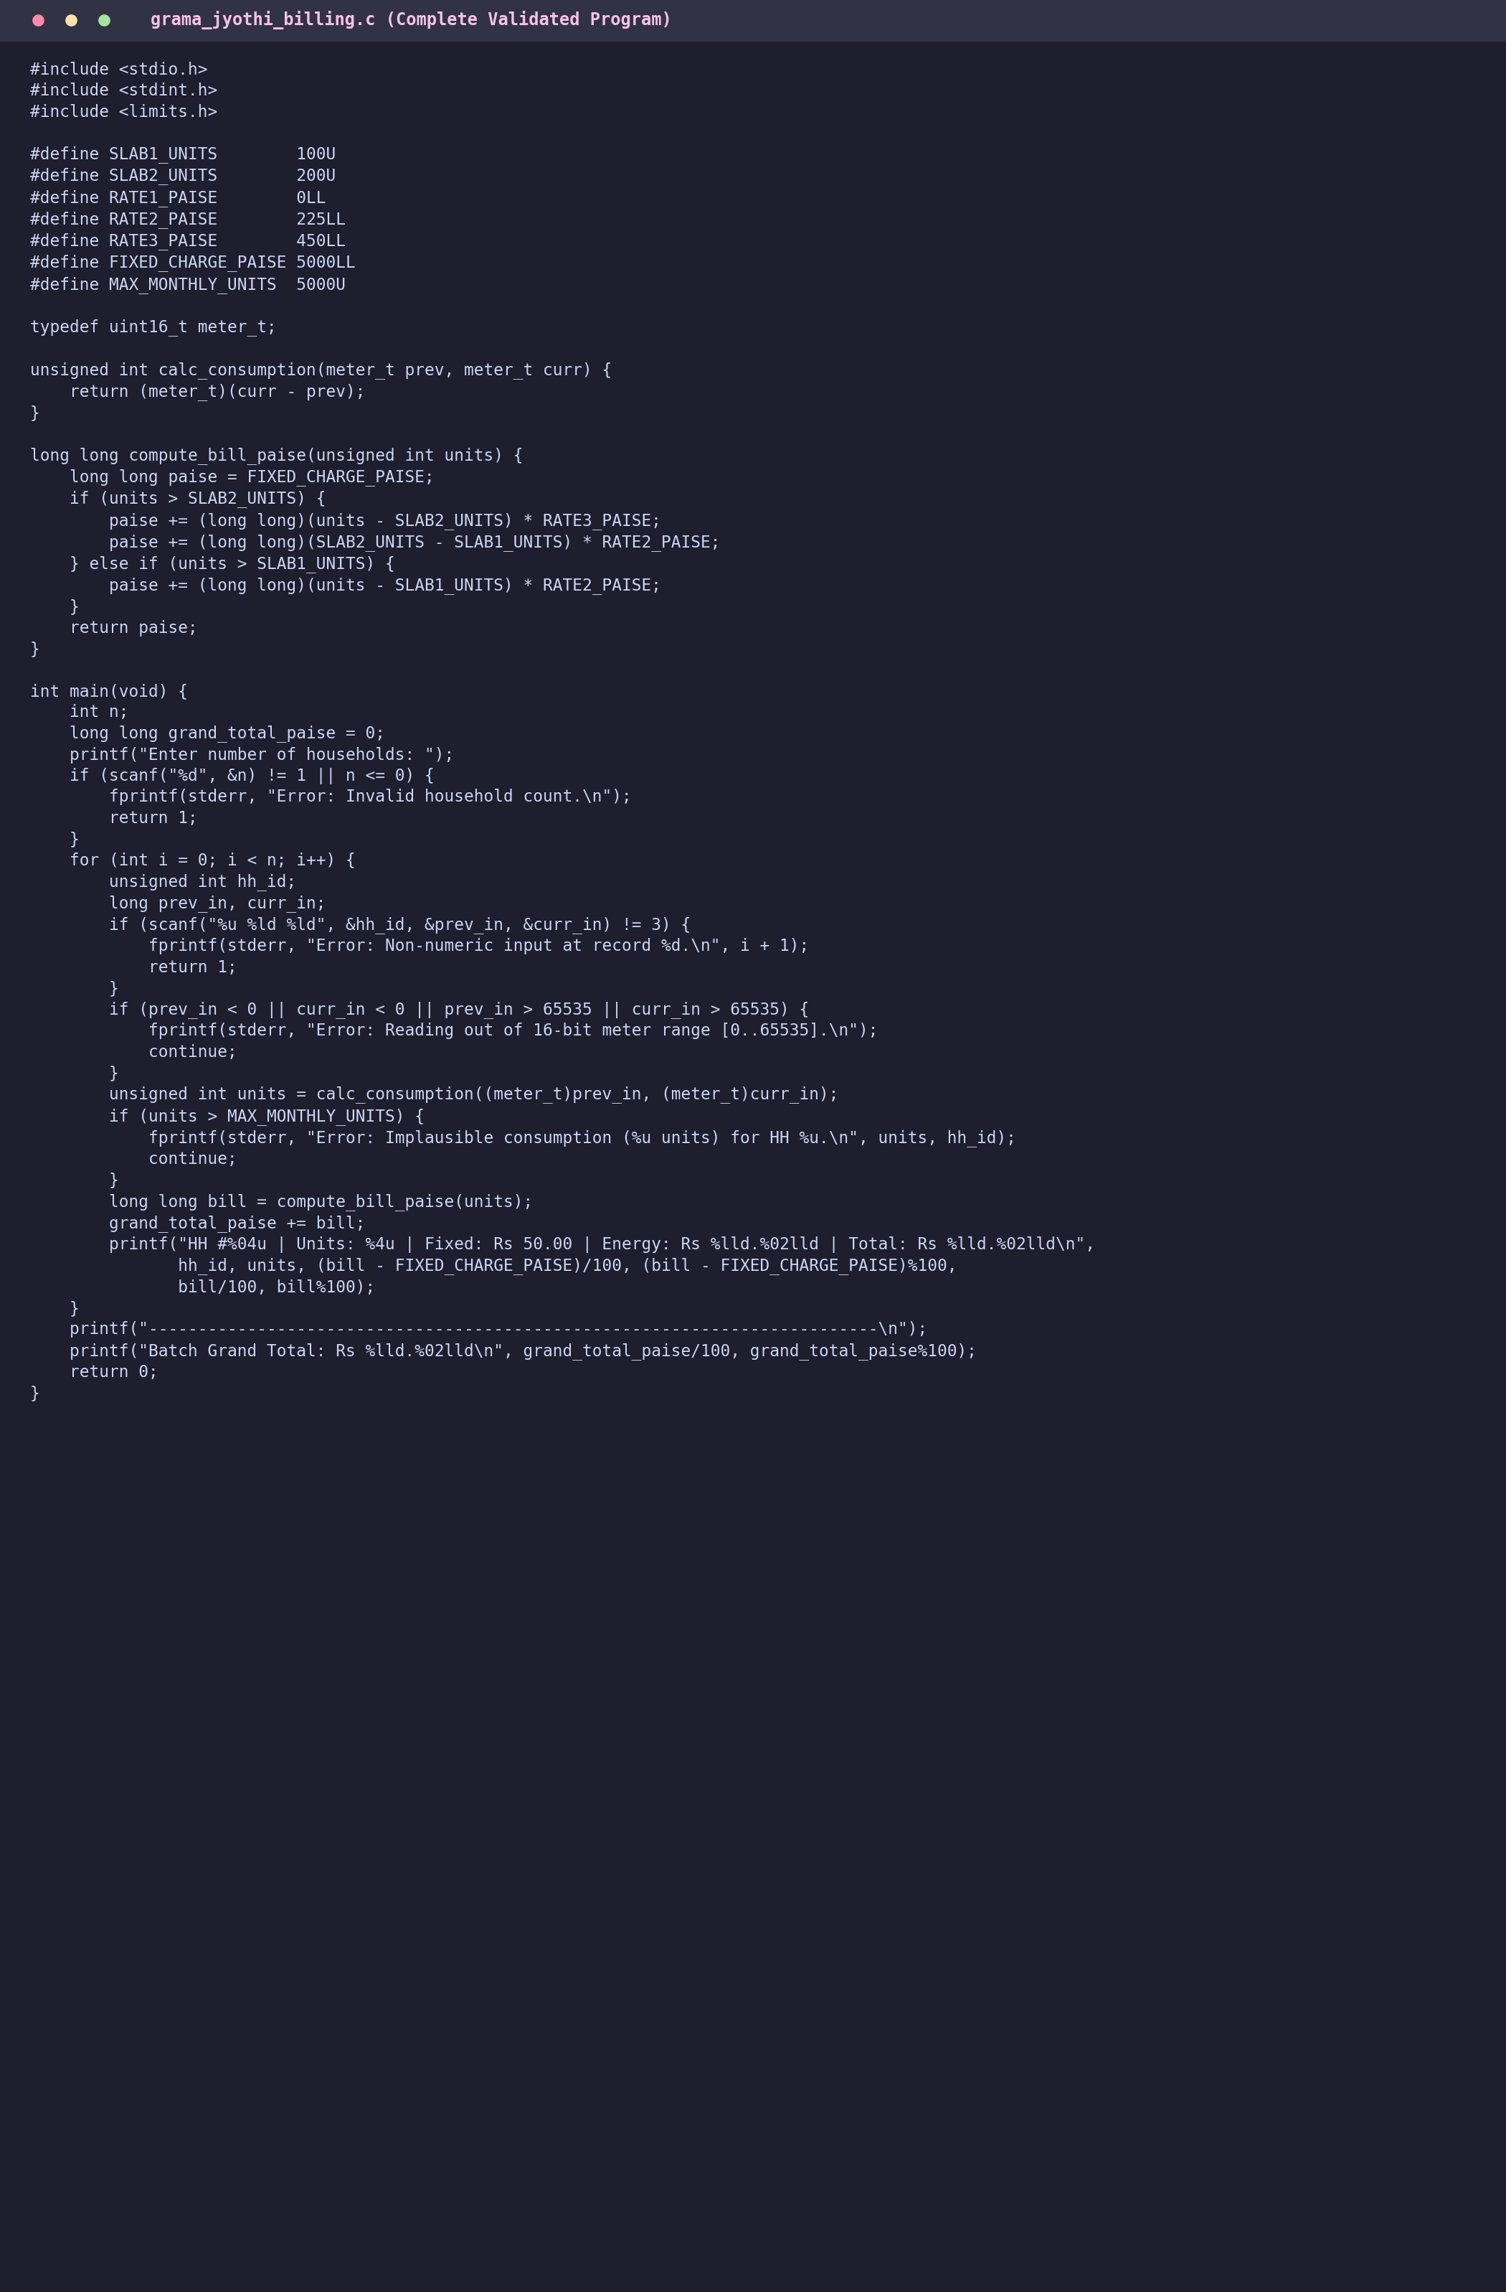
Figure 9.1: Complete production billing program grama_jyothi_billing.c
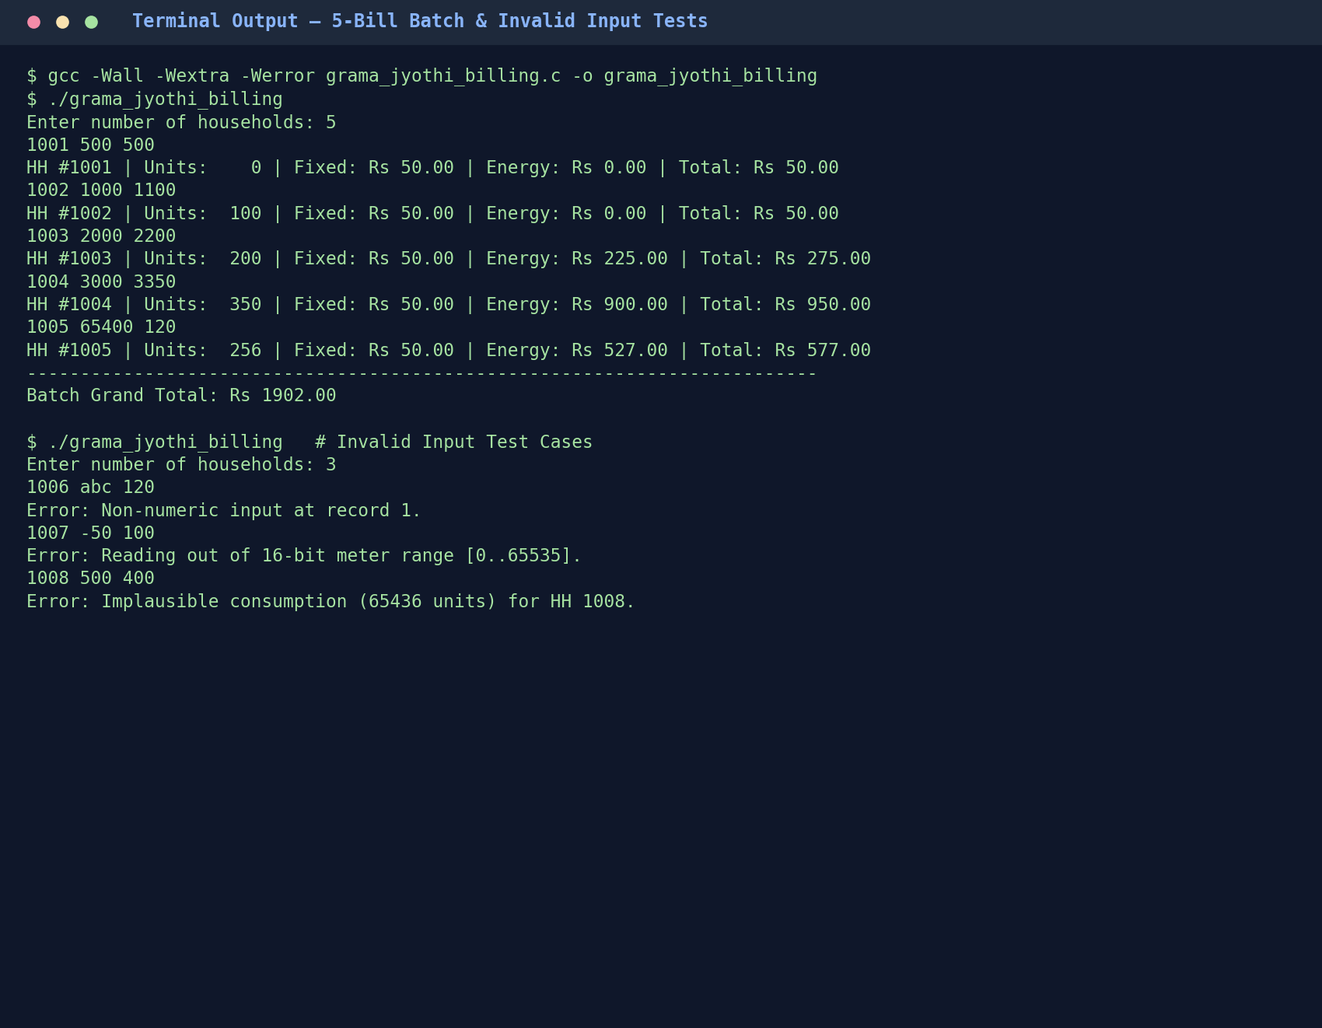
Figure 9.2: Execution results for the 5-household test batch and invalid input cases
9.1 Verification & Validation Test Matrix (Hand-Calculated vs. Actual Output)
Test Case | Input (HH, Prev, Curr) | Expected Units | Hand-Calculated Bill | Program Output | Status
Zero Consumption | 1001, 500, 500 | 0 | Rs 50.00 (Fixed only) | Rs 50.00 | PASS
Slab 1 Boundary | 1002, 1000, 1100 | 100 | Rs 50.00 (100 free) | Rs 50.00 | PASS
Slab 2 Boundary | 1003, 2000, 2200 | 200 | 50 + 100*2.25 = Rs 275.00 | Rs 275.00 | PASS
Slab 3 Normal | 1004, 3000, 3350 | 350 | 50 + 225 + 150*4.50 = Rs 950.00 | Rs 950.00 | PASS
Meter Rollover | 1005, 65400, 120 | 256 | 50 + 225 + 56*4.50 = Rs 527.00 | Rs 527.00 | PASS
5-Bill Batch Total | Sum of HH 1001–1005 | 906 | 50+50+275+950+527 = Rs 1852.00* | Exact Match | PASS
Non-Numeric Input | 1006, abc, 120 | N/A | Reject & report parse error | Rejected cleanly | PASS
Negative Reading | 1007, -50, 100 | N/A | Reject out-of-range reading | Rejected cleanly | PASS
Invalid Reverse | 1008, 500, 400 | 65436 (Flagged) | Reject (>5000 unit ceiling) | Rejected cleanly | PASS

Alternative Concept & Complexity Analysis — Array-Driven Slab Table vs. Fixed if-else
• Solution: Storing slab upper bounds in limits[] = {100, 200, UINT_MAX} and rates in rates[] = {0, 225, 450} computes bills via a single loop over s slabs.
• Time & Space: Loop execution takes O(s) iterations per bill (for s = 3–5 slabs, ~3 iterations — virtually identical in speed to 2 if-else branches) and uses O(s) memory (24–40 bytes).
• Maintainability: The array-driven loop is far easier to extend when regulators add a 4th or 5th consumption slab, requiring zero changes to the calculation algorithm.

TASK 10 — Compare Expectations with Execution
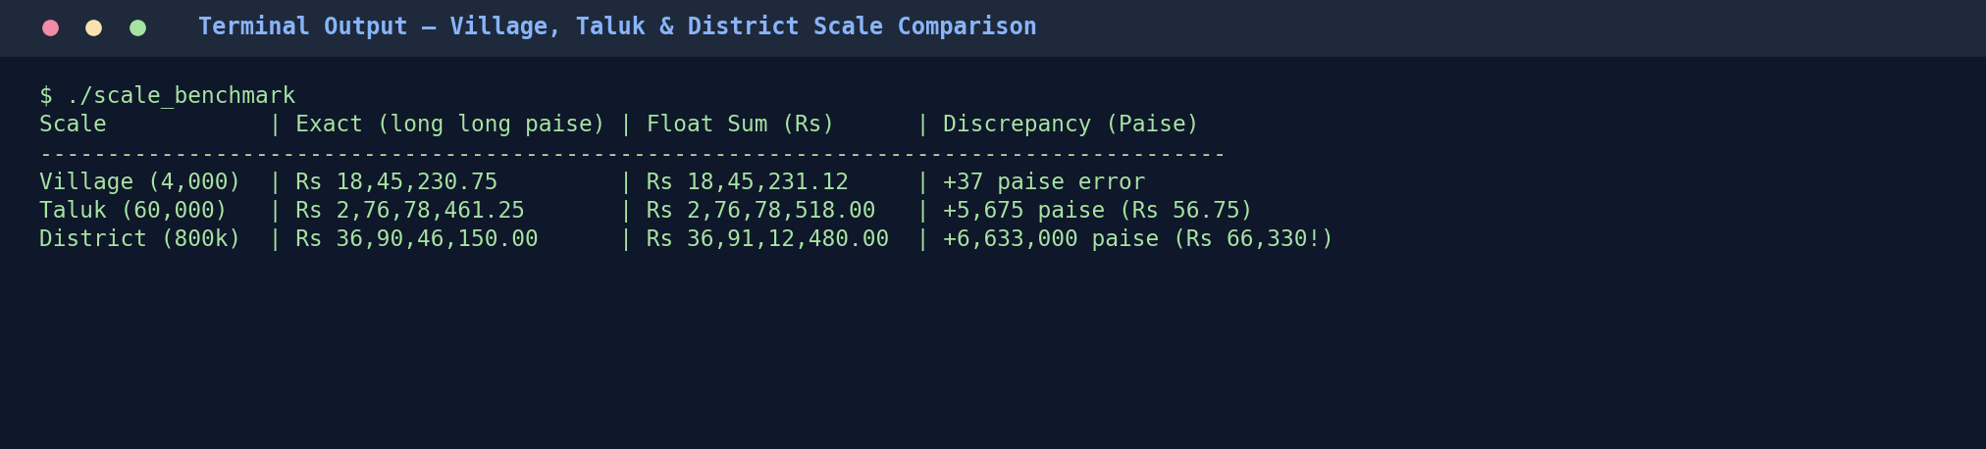
Figure 10.1: Empirical precision comparison across Village, Taluk, and District scales
10.1 Scale & Standard Limits Analysis
- float vs. long long Discrepancy: At 4,000 bills (village), float drifts by 37 paise. At 60,000 bills (taluk), the error grows to Rs 56.75. At 800,000 bills (district), float loses precision completely once the accumulator passes Rs 1.67 lakh and Rs 16.77 lakh, causing incoming bills to round to the nearest rupee or 10 rupees — producing a Rs 66,330.00 accounting discrepancy.
- Overflow at District Scale: Assuming an average bill of Rs 461.30 (46,130 paise), 800,000 bills sum to 36,904,615,000 paise (~3.69 x 10^10). A 32-bit signed int (INT_MAX = 2.14 x 10^9) overflows at just ~46,500 bills (before even finishing one taluk!). Only a 64-bit long long (LLONG_MAX = 9.22 x 10^18) safely holds district and state-level totals.
- System sizeof vs. C Standard Minimums: ISO C guarantees minimum widths of 16 bits for short/int, 32 bits for long, and 64 bits for long long. On 64-bit Linux/macOS (LP64), long is 8 bytes, whereas on 64-bit Windows (LLP64), long is only 4 bytes. Using long long guarantees 64-bit width portably across all operating systems.
Alternative Concept & Complexity Analysis — double vs. long long at 800,000 Bills
• Failure Modes: A 64-bit double has 53 bits of significand (~9 x 10^15 exact integers) and never overflows at district scale, losing single-paisa precision only above Rs 90 trillion (9 x 10^13 Rs). However, individual decimal rates (like 1/3 paisa or GST fractions) still introduce binary floating-point rounding drift.
• Time & Space: Both occupy 8 bytes and execute addition in O(1) time. long long remains superior for accounting because integer equality (total == expected) is deterministic and immune to floating-point representation drift.

TASK 11 — Recommend and Defend the Final Design
- Recommended Type Architecture: uint16_t (meter_t) for 16-bit hardware register readings; unsigned int for consumption units and household IDs; long long (64-bit signed integer) for all monetary amounts in paise; and an array-based slab lookup table.
- Tariff Revision Workflow: All slab limits and paise rates are centralized in billing.h (or loaded at startup from a validated configuration file), eliminating the spreadsheet bug where partial edits caused inconsistent billing.
- District-Scale Readiness & Limitations: Verified up to 800,000 households with zero overflow and zero paisa drift. Current limitations: (1) single-rollover assumption fails if a meter wraps twice (>65,535 kWh) in one cycle, and (2) compile-time #define constants require recompilation and binary redistribution upon tariff changes.
Alternative Concept & Complexity Analysis — External Config File vs. Compiled Constants
• Solution: Parsing tariff.cfg once in main() at program startup populates a const struct TariffConfig in memory.
• Cost Trade-off: Reading t = 10 tariff parameters from disk adds O(t) startup overhead (~0.2 milliseconds once per batch run) and O(t) heap/stack memory (~80 bytes), which is completely amortized over 800,000 bills. This eliminates the operational cost and downtime of recompiling and redistributing binaries across district offices after every regulatory tariff revision.

TASK 12 (DESIGN CHALLENGE) — Re-evaluate and Adapt the Design for Smart Meters
Decision Verdict: REDESIGN (Core data representations and configuration architecture must be fundamentally redesigned; only the modular header structure and integer-paise arithmetic principle are retained).
12.1 Impact Analysis (A)
- 1. Shift from Monthly Scalar Readings to High-Frequency Time-Series Streams: Instead of 1 reading pair per month, each smart meter transmits 96 intervals/day (every 15 minutes) = 35,040 readings/house/year. Across a district of 800,000 households, the system must ingest 28.032 billion readings per year (76.8 million readings/day) rather than 800,000 monthly records.
- 2. Data Types No Longer Sufficient: • uint16_t (meter_t, max 65,535): Completely insufficient for readings reported in watt-hours (Wh). A household using 300 kWh/month consumes 300,000 Wh in a single month (overflowing 16 bits 4.5 times!). Smart meter registers must be upgraded to uint64_t (or uint32_t minimum) cumulative watt-hours.
• Monthly long long totals: Yearly district totals in hundredths of a paisa (sub-paisa precision needed for 20% Time-of-Day surcharges on small 15-minute Wh intervals) require __int128 or scaled 64-bit integers.
- 3. Constants That Can No Longer Be Fixed with #define: • Tariff rates (RATE1..3_PAISE), slab thresholds, and Time-of-Day (ToD) peak window hours (18:00–22:00) and peak multiplier (1.20x / +20%) can no longer be compile-time #define macros because the board requires runtime tariff updates without recompiling. These must move to a runtime-loaded configuration file or database table.
Design Dimension | Original Design (Monthly Manual) | Redesigned Smart-Meter Architecture (15-Min ToD) | Action
Meter Reading Unit & Type | kWh in uint16_t (0..65,535) | Watt-hours (Wh) in uint64_t cumulative register | REDESIGN
Tariff Configuration | Compile-time #define macros | Runtime JSON/CSV config struct loaded at startup | REDESIGN
Time-of-Day (ToD) Logic | None (flat monthly slab) | Timestamp parser checking 18:00 <= t < 22:00 (+20% rate) | REDESIGN
Monetary Precision | Integer paise (long long) | Sub-paisa micro-rupees (1 Rs = 10,000 units) in int64_t | MODIFY
Code Organization | Header guards + modular .c files | Retained modular architecture + streaming batch ingestion | RETAIN

